SuperSpeed USB 3.0 Host Controller

General Description
It has the following features:
- SuperSpeed, High-Speed, Full-Speed, and Low-Speed Compatible with the xHCI specification from Intel Corporation
- PIPE 3-compliant SuperSpeed USB 3.0 Transceiver interface
- USB 2.0 UTMI+ (L3) interface

Architecture
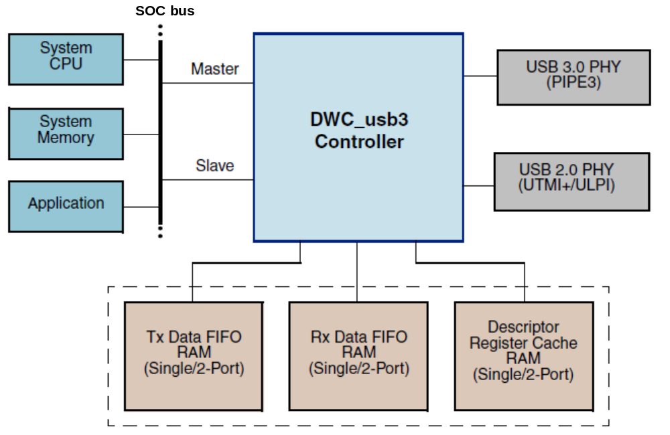
Figure : USB30 Architecture

Functional description
The USB3 use AXI Master interface for DMA operation, it provides an application hardware-level control to throttle the DMA read/write of data at the packet boundaries without involving software control.
The AHB Slave interface for read and write access to the core’s Control and Status Registers (CSRs) and debug access to the RAMs.
Three Single-port RAMs are used for Tx data buffering, Rx data prefetching, and descriptor and register caching. For SuperSpeed mode,
Both USB 2.0 and USB 3.0 operations can be simultaneously active to concurrently support USB 2.0 and USB 3.0 devices

